Vocal Tract as a Resonator

A continuous low pass resonator system has a transfer function given by

|  |  |
| --- | --- |
| $$H_{res}\left(s\right)=\frac{1}{s^{2}+\frac{ω_{n}}{Q}s+ω_{n}^{2}}$$ | (1) |

where $ω_{n}$ is the natural frequency in rad/s and $Q$ is the quality factor, or Q-factor, given by

|  |  |
| --- | --- |
| $$Q=\frac{ω_{r}}{2πB}$$ | (2) |

where $ω_{r}$ is the resonant frequency in rad/s and $B$ is the 3dB bandwidth.

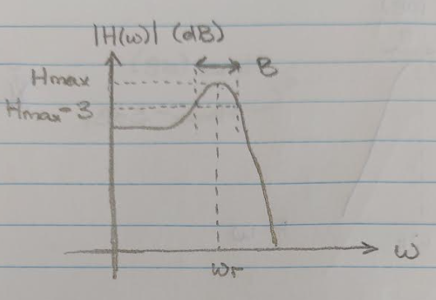

Assuming that $ω_{r}≈ω_{n}$, the transfer function can be expressed as

|  |  |
| --- | --- |
| $$H_{res}\left(s\right)=\frac{1}{s^{2}+2πB+{ω_{r}}^{2}}=\frac{1}{(s+πB+jω_{r})(s+πB-jω_{r})}.$$ | (3) |

A discrete resonator system can be obtained by applying an impulse invariant mapping, which maps the poles of the s-domain transfer function to poles in the z-domain,

|  |  |
| --- | --- |
| $$H_{res}\left(z\right)=\frac{1}{(1-e^{-\left(πB+jω_{r}\right)T}z^{-1})(1-e^{-\left(πB-jω_{r}\right)T}z^{-1})},$$ | (4) |
| $$H_{res}\left(z\right)=\frac{1}{1-2e^{-πBT}\cos\left(ω_{r}T\right)z^{-1}+e^{-2πBT}z^{-2}}.$$ | (5) |

where $T$ is the sampling period in seconds.

The vocal tract filter can be modelled using a cascade of discrete low pass resonators,

|  |  |
| --- | --- |
| $$V\left(z\right)=\frac{1}{\prod_{i=1}^{K}{\left(1-2e^{-πB_{i}T}\cos\left(2πF_{i}T\right)z^{-1}+e^{-2πB_{i}T}z^{-2}\right)}}$$ | (6) |

where $K$ is the maximum number of formants that can be captured by the model, $F_{i}$ is the $i$-th formant frequency and $B_{i}$ is the 3dB bandwidth of the $i$-th formant.